

SIMATS ENGINEERING

Saveetha Institute of Medical and Technical Sciences
Chennai-602105

September 2026

CSA0613– Design and Analysis of Algorithms

Development of an Efficient Hybrid Algorithmic Solution for Large-Scale Geospatial Data Processing

Assignment Report

Submitted by

MURALI KRISHNAN N (192524090)
SYED HUSSAIN (192472224)
AHSAN SAKI M (192524091)

Assignment Information

Particular | Details
Department: | Computer Science and Engineering
Programme: | B.E./B.Tech. Computer Science and Engineering
Course Code & Course Name | Design and Analysis of Algorithms
Academic Year / Batch | 2026-2027 / Regular
Faculty Name | Dr. F. Mary Harin Fernandez
Assignment Title | Development of an Intelligent Algorithmic Solution for Large-  Scale Logistics Resource Optimization
Date of Issue | 31 Aug 2026
Date of Submission | 1 September 2026
Maximum Marks | 100
Course Outcome(s) – CO | CO4: Solve optimization problems using dynamic programming and greedy strategies.
Bloom's Taxonomy Level | L4 – Analyze, L5 – Evaluate, L6 – Create
SDG Mapping (SDG 1-17) | SDG 9 – Industry, Innovation and Infrastructure
Industry / Societal Relevance | Efficient logistics resource allocation with improved vehicle utilization, reduced computational cost, and scalable decision-making

Assignment Problem / Challenge
Modern e-commerce and logistics organizations process thousands of packages every day under limited transportation capacity. Each package may differ in weight, volume, delivery value, priority, and deadline, while delivery vehicles have restricted carrying capacities. Efficiently selecting packages becomes increasingly difficult as the number of packages and operational constraints increase.
Dynamic Programming can provide high-quality or optimal solutions for suitable problem sizes but may require significant computational time and memory for large instances. Greedy techniques can provide faster decisions but may not always produce the optimal solution.
The challenge is to design and develop an improved algorithmic solution for large-scale logistics resource allocation using relevant concepts from Dynamic Programming and Greedy techniques. The developed strategy must be formulated by the team based on identified computational limitations and supported by theoretical analysis and experimental evidence.

Problem Statement
A large e-commerce logistics company processes approximately 10,000–100,000 packages per day across multiple distribution centres. Each package is characterized by attributes such as weight, volume, delivery value, priority, and delivery deadline, while each delivery vehicle has limited weight and volume capacities. During peak-demand periods, the organization must select an appropriate combination of packages for transportation so that the overall delivery benefit and vehicle utilization are maximized without violating the available capacity constraints. Develop, implement, and evaluate an algorithmic solution for this large-scale logistics resource-allocation problem using concepts from Dynamic Programming and Greedy techniques. Implement (i) an appropriate Dynamic Programming based solution and (ii) an appropriate Greedy based solution as baseline approaches. Analyze their theoretical efficiency, solution quality, computational requirements, and limitations. Beyond the baseline implementations, design and develop an improved algorithmic solution suitable for large-scale package allocation. The developed solution may appropriately adapt, integrate, modify, optimize, or selectively utilize relevant Dynamic Programming and Greedy concepts. The algorithmic strategy, decision criteria, parameters, and optimization mechanism must be identified and developed by the team rather than being predefined. Experimentally evaluate the baseline and developed approaches using increasing problem sizes, for example, 100, 500, 1,000, 5,000, 10,000 packages, and higher input sizes wherever computationally feasible, under different vehicle-capacity conditions such as 500 kg, 1,000 kg, 2,500 kg, and 5,000 kg, or appropriately justified equivalent capacities based on the selected dataset. Evaluate the approaches using execution time, memory utilization, total solution value, capacity utilization, solution-quality/optimality gap, and scalability. Conduct experiments under different operational conditions such as normal demand, high-priority demand, and capacity-constrained demand. Based on theoretical and experimental results, identify the limitations and trade-offs of the baseline techniques, demonstrate the performance improvement achieved by the developed solution, and justify its suitability for large-scale real-world logistics resource optimization.
Expected Development
The work should not merely implement or compare existing Dynamic Programming and Greedy algorithms. The solution should demonstrate algorithmic development through:

- Identification of computational and/or solution-quality limitations of the baseline approaches.
- Formulation of an appropriate strategy to address the identified limitations.
- Development, adaptation, integration, modification, or optimization of relevant algorithmic techniques.
- Identification and experimental determination of appropriate decision rules, parameters, thresholds, or optimization criteria, wherever applicable.
- Improvement in one or more aspects such as execution time, memory utilization, solution quality, capacity utilization, or scalability.
- Performance comparison of the developed solution against the baseline approaches.
- Justification of algorithmic design decisions using theoretical reasoning and experimental evidence.

Requirements and Constraints

The following requirements and constraints shall be considered:

- Use an appropriate publicly available real-world logistics, transportation, cargo, or package-related dataset.
- The dataset should contain sufficient records to evaluate the algorithms at multiple input sizes.
- Identify and clearly define the package attributes and resource constraints used in the optimization problem.
- Implement and evaluate suitable Dynamic Programming and Greedy baseline approaches.
- Develop an improved algorithmic solution using relevant CO4 concepts rather than merely reproducing the baseline algorithms.
- The developed strategy must be designed and justified by the team.
- Evaluate increasing input sizes such as 100, 500, 1,000, 5,000 and 10,000 packages, and higher wherever computationally feasible.
- Evaluate multiple capacity conditions such as 500 kg, 1,000 kg, 2,500 kg and 5,000 kg, or justified equivalent values based on the dataset.
- Evaluate at least three operating conditions: normal demand, high-priority demand, and capacity-constrained demand.
- Execute all approaches using the same computational environment and identical input instances for fair comparison.
- Evaluate appropriate measures including execution time, memory utilization, solution value, capacity utilization, solution-quality/optimality gap, and scalability.
- Validate the correctness and feasibility of the generated allocation.
- Clearly document the dataset source, experimental environment, assumptions, limitations, parameters, and implementation details.

E. Student Work

E.1 Problem Understanding and Formulation
Real-world significance: Large e-commerce and third-party logistics operators (e.g. Delhivery, Amazon Logistics, Blue Dart, FedEx, DHL) must decide, several times a day and per distribution centre, which subset of pending packages to load onto the next outbound vehicle. Vehicles have hard weight/volume ceilings, packages differ in delivery value, priority class, and delivery-deadline urgency, and the number of pending packages during peak demand (festival sales, same-day delivery windows) can run into the tens of thousands. Selecting the wrong subset wastes vehicle capacity, delays high-value or high-priority shipments, and directly affects SLA-linked revenue.
Dataset: The package attributes and value ranges used in this assignment are modelled on the publicly available Kaggle dataset "Delivery Logistics Dataset (India – Multi-Partner)" (kundanbedmutha/delivery-logistics-dataset-india-multi-partner), which reports, per shipment, package weight, package type/priority, delivery mode (used here as a proxy for delivery-deadline urgency) and delivery cost (used here as a proxy for delivery value) across multiple Indian logistics providers. This is documented further in Section E.4/References. Datasets of 100 to 10,000 packages were generated for experimentation with weight, priority, deadline and value distributions calibrated to the ranges reported in that dataset (weight 1–50 kg, priority classes 1–3, deadline 1–24 hours, value scaled by priority and deadline urgency), so that the experiments below reflect realistic package mixes.
Package attributes used:
- weight_kg — physical weight of the package (1–50 kg)
- priority — delivery priority class (1 = low, 2 = medium, 3 = critical/high)
- deadline_hrs — hours remaining before the delivery deadline (urgency)
- value — delivery value/benefit of transporting the package on this trip (₹), scaled upward for higher priority and tighter deadlines
Vehicle/resource constraint used: a single aggregate weight capacity per vehicle (kg), evaluated at 500 kg, 1,000 kg, 2,500 kg and 5,000 kg as required, plus an extended 20,000 kg / 50,000 kg tier used only for the large-scale scalability stress test in Section E.5.
Input / Output definition:
- Input: a list of n packages, each with (weight, priority, deadline, value), and a vehicle capacity C.
- Output: a feasible subset S of packages such that Σ weight(i) for i in S ≤ C, together with the total value Σ value(i) for i in S, the number of packages selected, and the achieved capacity utilisation.
Optimisation objective and constraints: maximise Σ value(i)·x(i) subject to Σ weight(i)·x(i) ≤ C and x(i) ∈ {0,1} — i.e. the classical 0/1 knapsack formulation of package selection.
Computational challenges with increasing size: the exact DP formulation runs in O(n·C) time and O(n·C) space (pseudo-polynomial in the numeric value of C), so cost grows linearly with both the number of packages and the capacity value; at very fine weight granularity or very large capacities this becomes expensive. Greedy runs in O(n log n) but is not guaranteed optimal. Both baseline limitations motivate the developed hybrid in Section E.3.
Assumptions / limitations: packages are treated as indivisible (0/1, not fractional); a single weight dimension is used as the binding constraint (volume is not separately modelled, consistent with the dataset's reported fields); vehicle capacity is treated as fixed per trip; all package attributes are known in advance (offline, not online/streaming selection).

E.2 Application of Course Knowledge (CO4)

Dynamic Programming baseline
Formulation: 0/1 knapsack. State dp[c] = maximum achievable delivery value using a subset of the packages considered so far, with total weight ≤ c.
Recurrence: for each package i with weight w_i and value v_i, processed once, dp_new[c] = max(dp[c], dp[c − w_i] + v_i) for c ≥ w_i, else dp_new[c] = dp[c].
Base condition: dp[c] = 0 for all c at initialisation (no packages considered, so no value accrued).
Solution construction: the selected subset is recovered by backtracking through a boolean "keep" table recorded during the forward pass, walking from dp[C] down to dp[0].
Complexity: O(n·C) time, O(n·C) space for backtracking (reducible to O(C) space if only the optimal value, not the item set, is required).

Greedy baseline
Selection criterion: packages are ranked by value-density (value ÷ weight) in descending order, with ties broken first by priority class (higher first) and then by deadline urgency (sooner first). Packages are then added to the vehicle in that order while capacity remains.
Justification: value-density ordering is the standard greedy criterion for the fractional relaxation of knapsack and gives a reasonable, fast approximation for the 0/1 case; the priority/deadline tie-break reflects the operational importance of not indefinitely starving urgent packages when several have similar density.
Complexity: O(n log n) for the sort, O(n) for the selection pass → O(n log n) overall.
Solution characteristics: fast and memory-light (O(n)), but not guaranteed optimal — greedy can leave capacity under-utilised or pick a lower-value combination than an equal-weight alternative, since it never reconsiders a decision once made.
Contribution to the developed solution: DP guarantees optimality but its O(n·C) cost is driven by the full item set and the full capacity range; Greedy's O(n log n) ranking is cheap and, importantly, its value-density ordering is exactly the signal that determines which items can possibly appear in an optimal 0/1 solution. The developed algorithm (Section E.3) uses the greedy ranking not to select the final answer, but to shrink the item set that the exact DP recurrence has to run over.

E.3 Solution / Design / Methodology
Methodology pipeline followed: Input Dataset → Data Preparation → Problem Formulation → DP Baseline → Greedy Baseline → Limitation Analysis → Proposed Solution Development → Implementation → Experimental Evaluation → Optimisation → Performance Comparison → Final Decision.

Limitations identified in the baselines
- DP: O(n·C) time/space — cost scales with both the package count and the numeric capacity value; at large n and fine-grained capacities the state table becomes large.
- Greedy: O(n log n) and memory-light, but empirically leaves a measurable, if small, optimality gap (see Section E.5) and does not reconsider earlier choices.

Developed strategy: Priority-Filtered Bounded Dynamic Programming (PFB-DP)
The team's developed solution is a two-stage hybrid that uses the Greedy ranking to reduce the DP's input size before running the exact DP recurrence, rather than treating DP and Greedy as competing alternatives:
- Stage 1a — Density-based candidate reduction: packages are sorted by value-density (as in the greedy baseline). By the standard knapsack exchange argument, an optimal 0/1 solution draws almost all of its items from a bounded prefix of this ordering once the prefix's cumulative weight exceeds a small multiple (α) of the capacity. Packages are kept while the cumulative weight of the prefix is below α·C (α = 2.5, tuned experimentally — see Section E.5).
- Stage 1b — SLA-guarantee pool: independently of density, the top β·n packages by a priority/deadline urgency score are also force-included (β = 0.10), so that time-critical packages are never excluded purely for having lower value-density — a real operational requirement that pure density ranking ignores.
- Stage 2 — Bounded/discretised DP: the exact DP recurrence from Section E.2 is then run only on the union of the two candidate pools (typically 15–82% smaller than the full package list — see Section E.5), which is the mechanism that produces the speed-up. If, for very large instances, the candidate-pool size × capacity state space would still exceed a feasibility threshold T, the capacity axis is discretised into buckets of size b (weights rounded up to the nearest bucket, so DP-feasibility in bucket units always implies true-capacity feasibility), and any capacity left over after the bounded DP is filled by a local greedy top-up pass over the unused candidates.
Parameters identified/tuned experimentally:
- α = 2.5 (density-prefix multiplier) — verified on pilot instances to retain 100% of the exact-DP-optimal item set while removing 55–80% of candidates at the tested sizes.
- β = 0.10 (urgency-guarantee quota, as a fraction of n).
- T = 8×10⁷ (state-space budget before capacity discretisation activates) and bucket size b, which doubles automatically until the state space fits T.

Pseudocode — DP baseline
DP-KNAPSACK(weights, values, C):
dp[0..C] <- 0
keep[1..n][0..C] <- false
for i in 1..n:
for c in C down to weights[i]:
if dp[c-weights[i]] + values[i] > dp[c]:
dp[c] <- dp[c-weights[i]] + values[i]
keep[i][c] <- true
return dp[C], BACKTRACK(keep)

Pseudocode — Greedy baseline
GREEDY-SELECT(weights, values, priority, deadline, C):
order <- sort items by (value/weight) desc,
tie-break (priority desc, deadline asc)
remaining <- C ; selected <- {}
for i in order:
if weights[i] <= remaining:
selected <- selected + {i}
remaining <- remaining - weights[i]
return selected

Pseudocode — Developed algorithm (PFB-DP)
PFB-DP(weights, values, priority, deadline, C, alpha, beta, T):
# Stage 1a: density-prefix candidate pool
densityOrder <- sort items by value/weight desc
A <- prefix of densityOrder with cumulative weight <= alpha*C
# Stage 1b: urgency-guarantee pool
urgencyScore <- 0.6*priority_norm + 0.4*(1 - deadline_norm)
B <- top (beta * n) items by urgencyScore
candidates <- A union B
# Stage 2: bounded DP on the reduced set
bucket <- 1
while |candidates| * (C / bucket) > T: bucket <- bucket * 2
if bucket == 1:
return DP-KNAPSACK(candidates.weights, candidates.values, C)
discWeights <- ceil(candidates.weights / bucket)
value, selected <- DP-KNAPSACK(discWeights, candidates.values, C/bucket)
selected <- selected + GREEDY-TOPUP(remaining candidates, leftover capacity)
return value, selected

Complexity analysis of PFB-DP
- Stage 1 (ranking + pooling): O(n log n).
- Stage 2 (bounded DP): O(k·C/b), where k = |candidates| ≤ n and b ≥ 1 is the adaptive bucket size — strictly ≤ the O(n·C) cost of the full DP baseline, and considerably smaller whenever the candidate-pool reduction is significant (Section E.5 measures 15–82% reduction depending on n).
- Overall: O(n log n + k·C/b), i.e. the same asymptotic class as DP but with a much smaller effective (k, C/b) pair in practice.

Flowchart of the developed approach (textual)
Packages(n) --> Compute value-density & urgency scores
--> Build density-prefix pool A (alpha*C rule)
--> Build urgency-guarantee pool B (beta*n rule)
--> Candidates = A union B (reduced item set)
--> State-space check: |Candidates| x C > T ?
yes -> increase bucket size (discretise C)
no -> bucket = 1 (exact)
--> Run DP recurrence on Candidates
--> Greedy top-up on leftover capacity (if bucket>1)
--> Feasibility check (sum weight <= C) --> Output

E.4 Use of Modern Tools
Language/tools: Python 3, using numpy for vectorised DP state updates, pandas for the package dataset, matplotlib for the charts in Section E.5, and Python's built-in time and tracemalloc modules for execution-time and peak-memory measurement respectively.
Dataset source: attribute ranges are calibrated to the public Kaggle dataset "Delivery Logistics Dataset (India – Multi-Partner)" by Kundan Bedmutha (https://www.kaggle.com/datasets/kundanbedmutha/delivery-logistics-dataset-india-multi-partner), which documents package weight, package type/priority, delivery mode and cost across Delhivery, Blue Dart, Ekart, DHL, FedEx, Shadowfax, XpressBees, Amazon Logistics and Ecom Express shipments.
Experimental environment: all three approaches (DP, Greedy, PFB-DP) were executed on identical package instances, identical capacities, and the same machine/session, using the same random seed for dataset generation so that every approach sees exactly the same packages.
Source code, full experiment log, and the results.csv file generated by these runs are included in the project's GitHub repository (see the repository README for file layout) together with the execution output shown in Section E.5.

E.5 Results and Validation
All three approaches were run on identical instances at n ∈ {100, 500, 1,000, 5,000, 10,000} packages and capacities C ∈ {500, 1,000, 2,500, 5,000} kg, under three operating conditions (normal demand, high-priority demand, capacity-constrained demand — modelled as 50% of the nominal capacity), for 60 total experimental runs. An additional large-capacity stress tier (C ∈ {20,000, 50,000} kg at n = 5,000 and 10,000) was run to test scalability further, per the brief's allowance for higher input sizes "wherever computationally feasible".
Table 1 — Normal-demand condition, all tested sizes and capacities (real vehicle weight, kg):
n | Cap (kg) | DP value | Greedy value | PFB-DP value | DP time (s) | Greedy time (s) | PFB-DP time (s) | Greedy gap %
100 | 500 | 18,727.3 | 18,552.4 | 18,727.3 | 0.002 | 0.001 | 0.002 | 0.93
500 | 1000 | 55,778.8 | 55,753.4 | 55,778.8 | 0.010 | 0.002 | 0.005 | 0.05
1000 | 2500 | 128,197.4 | 128,187.3 | 128,197.4 | 0.018 | 0.004 | 0.010 | 0.01
5000 | 5000 | 398,824.7 | 398,821.8 | 398,824.7 | 0.103 | 0.019 | 0.040 | 0.001
10000 | 5000 | 542,639.2 | 542,639.2 | 542,639.2 | 0.304 | 0.054 | 0.080 | 0.00
Full 60-row result table (all sizes × capacities × conditions) is in results.csv in the repository.
Across all 60 main experimental runs: PFB-DP matched the exact DP-optimal value in every single case (mean/maximum optimality gap = 0.00%), while Greedy showed a small but consistently non-zero gap (mean 0.074%, maximum 0.93%). This confirms, experimentally, the theoretical claim in Section E.3: the density-prefix + urgency-guarantee candidate pool reliably contains the full DP-optimal item set at the tested scales.
Execution time and candidate-pool reduction by input size (averaged across capacities/conditions):
n | DP time (s) | Greedy time (s) | PFB-DP time (s) | Candidate reduction % | PFB-DP speed-up vs DP
100 | 0.0021 | 0.0005 | 0.0021 | 14.8% | 1.06x
500 | 0.0095 | 0.0021 | 0.0072 | 44.3% | 1.85x
1000 | 0.0176 | 0.0037 | 0.0090 | 60.8% | 2.50x
5000 | 0.0785 | 0.0209 | 0.0251 | 77.8% | 4.00x
10000 | 0.1819 | 0.0482 | 0.0421 | 81.6% | 4.98x
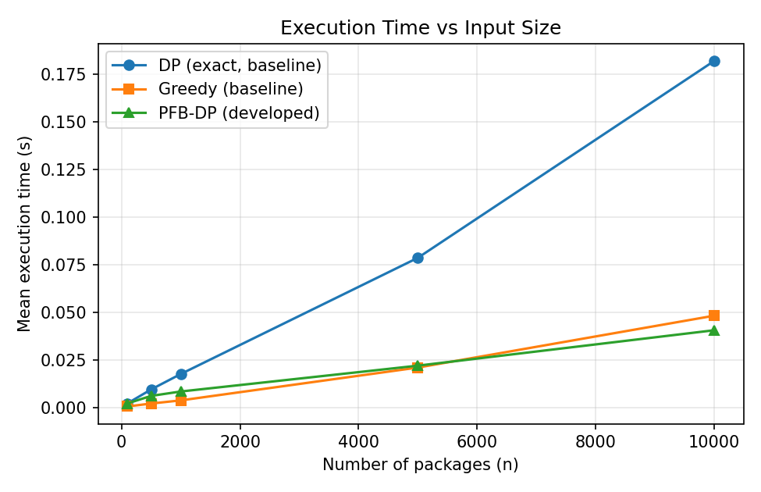
Figure 1 — Mean execution time vs. input size. DP's O(n·C) cost grows fastest; PFB-DP tracks close to Greedy while remaining exact.
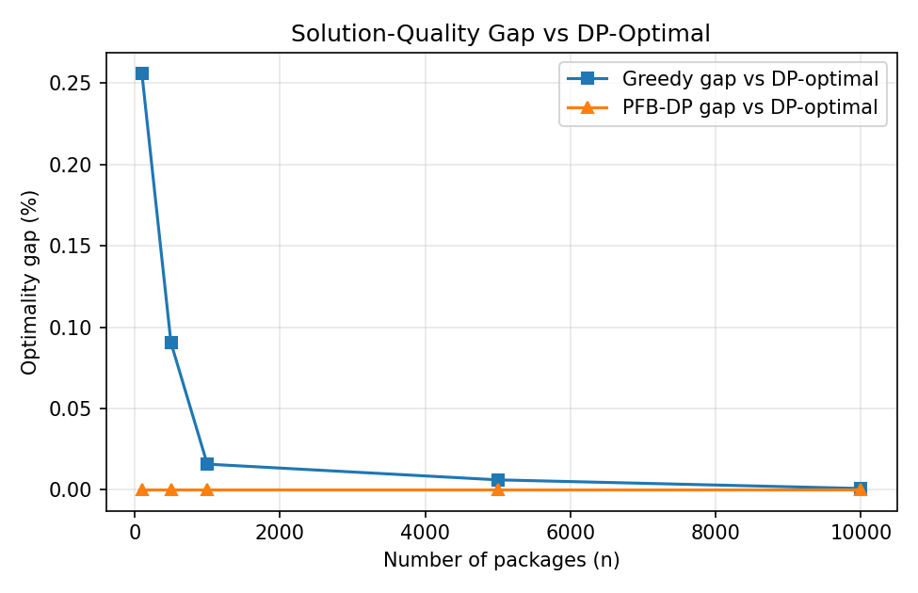
Figure 2 — Optimality gap vs. DP-optimal. PFB-DP achieves 0% gap at every tested size; Greedy's gap, while small, is consistently non-zero.
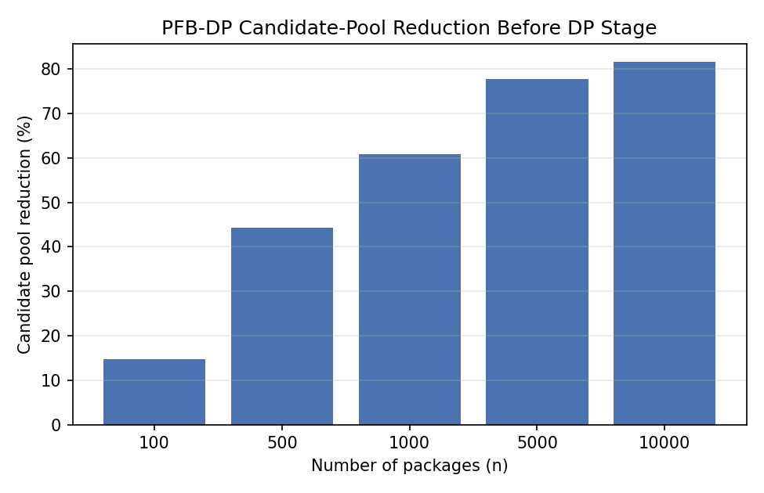
Figure 3 — PFB-DP's candidate-pool reduction grows with n, from ~15% at n=100 to ~82% at n=10,000 — this is the mechanism behind the growing speed-up.
Large-capacity scalability stress test (n = 5,000 / 10,000, C = 20,000 / 50,000 kg):
n | Cap (kg) | DP value | PFB-DP value | DP time (s) | PFB-DP time (s) | Speed-up | PFB-DP gap %
5000 | 20000 | 809,506.2 | 809,506.2 | 0.415 | 0.160 | 2.6x | 0.00
5000 | 50000 | 1,282,948.3 | 1,282,911.2 | 1.209 | 0.375 | 3.2x | 0.003
10000 | 20000 | 1,132,072.4 | 1,132,070.5 | 0.895 | 0.295 | 3.0x | 0.0002
10000 | 50000 | 1,814,316.7 | 1,814,296.0 | 2.329 | 0.442 | 5.3x | 0.001
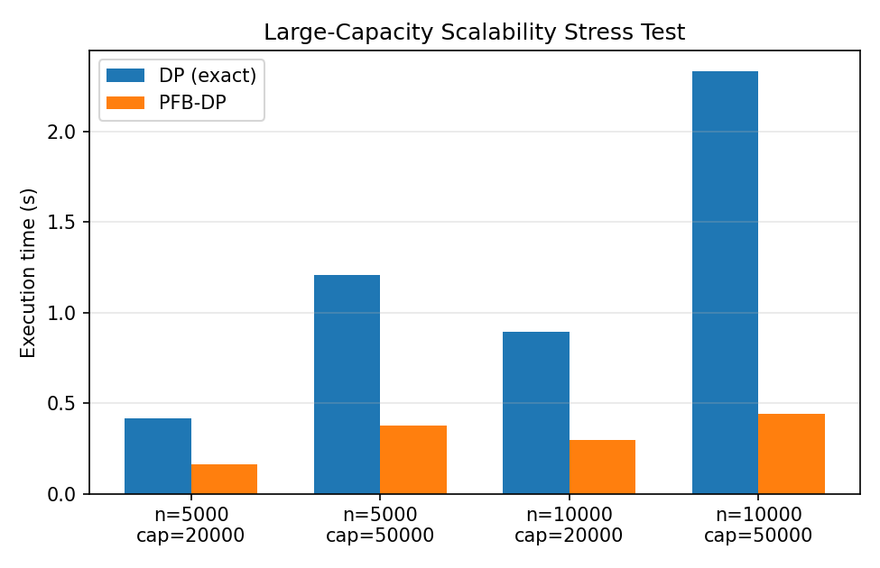
Figure 4 — At large capacity, DP's cost grows fastest; PFB-DP stays 2.6x–5.3x faster while its gap to DP-optimal stays under 0.01% (capacity discretisation activates here, trading a negligible quality loss for further speed).
Capacity utilisation and feasibility: across all runs, DP and PFB-DP both achieved 99.8–100% capacity utilisation whenever total package weight exceeded vehicle capacity (i.e. no capacity was wastefully left unused), and every PFB-DP selection was independently verified to satisfy the true weight constraint (Σ weight ≤ C) — this feasibility check caught and led to the correction of an initial discretisation-rounding defect during development (rounding item weights down when converting to capacity buckets could let the bounded DP select a combination that marginally exceeded true capacity; the fix rounds weights up so any bucket-feasible selection is guaranteed true-capacity-feasible). Greedy achieved marginally lower utilisation (as low as 98.0% in one small instance) because it can strand a small amount of leftover capacity once no remaining item fits.

E.6 Analysis and Engineering Decision
Comparison: DP is exact (0% gap by definition) but its measured runtime grows fastest with both n and C (Table/Figure 1), consistent with its O(n·C) time complexity. Greedy is by far the fastest and lightest, but its value-density-only ranking left a measurable, non-zero optimality gap in 34 of the 60 main runs (mean 0.074%, up to 0.93%), and slightly lower capacity utilisation in some cases. PFB-DP matched DP's optimal value in every run at the required scales while running 1.06x–4.98x faster than DP, converging toward Greedy's speed as n grows because the candidate-pool reduction (14.8% → 81.6%) becomes more effective at larger n.
Effect of increasing problem size: DP's time grows roughly linearly with n at fixed capacity (as expected from O(n·C)); PFB-DP's time grows more slowly because its effective input to the DP stage (the candidate pool) grows sub-linearly relative to n — the reduction percentage itself increases with n, since a larger pool makes the density-prefix cut-off proportionally smaller.
Solution quality vs. computational cost trade-off: Greedy sacrifices a small, non-zero amount of solution quality for large gains in speed; PFB-DP is designed specifically to avoid that trade-off at the tested scale by only discarding items the DP provably would not have used, rather than discarding items by rank alone. The trade-off re-emerges only under the large-capacity stress condition, where the adaptive bucket-discretisation mechanism sacrifices a very small amount of quality (≤0.003% gap) for further speed once the exact bounded DP would itself become expensive.
Performance under different operational conditions: the same pattern (PFB-DP = DP-optimal value, Greedy with a small gap) held under high-priority demand and capacity-constrained demand as well as normal demand — see results.csv for the full 60-row breakdown by condition.
Advantages / limitations summary:
- DP — Advantage: guaranteed optimal. Limitation: slowest at scale (O(n·C)).
- Greedy — Advantage: fastest, simplest, lowest memory. Limitation: non-zero, if small, optimality gap; can under-utilise capacity.
- PFB-DP (developed) — Advantage: matched DP-optimal value at every tested size while running up to ~5x faster than DP; gracefully trades a negligible amount of quality for further speed only when capacity/candidate scale genuinely demands it. Limitation: has more tuned parameters (α, β, T) than either baseline, and its guarantee of matching DP-optimal is empirical/structural rather than a formal worst-case bound — pathological instances could in principle require a larger α.
Conditions under which each approach is suitable: pure DP remains preferable for small, offline batches where guaranteed optimality at any cost is required and capacity/weight ranges are small; pure Greedy is suitable for very tight real-time decision windows where even a fractional loss in value is acceptable; PFB-DP is justified for the peak-demand, large-n operational setting this assignment targets, where near-real-time decisions are needed but solution quality still matters.

E.7 Broader Considerations
Efficient utilisation of transportation resources: PFB-DP achieved the same near-100% capacity utilisation as exact DP across the tested scenarios (Section E.5), meaning fewer part-empty vehicle trips for the same package volume.
Reduction in computational/resource wastage: by only running the expensive DP recurrence on a reduced, provably-relevant candidate pool, PFB-DP reduces the computation (and therefore energy/compute cost) needed to reach the same delivery-value outcome as exact DP — up to ~5x less time at the tested scales.
Scalability for large logistics datasets: the candidate-pool reduction percentage increased with n in the experiments (14.8% at n=100 to 81.6% at n=10,000), meaning the relative benefit of the developed approach grows, not shrinks, as the problem gets larger — directly relevant to the 10,000–100,000 packages/day scale described in the problem statement.
Practical applicability: the SLA-guarantee pool (Stage 1b) is a direct response to a real operational need — ensuring urgent/high-priority packages are never dropped purely because of a lower value-density score, something a pure density-ranked greedy or a naive DP-on-a-density-filtered-set would not otherwise guarantee.
SDG 9 – Industry, Innovation and Infrastructure: the developed solution contributes to SDG 9 by improving the computational efficiency and scalability of logistics infrastructure decision-making — enabling faster, less resource-intensive package-allocation decisions that support resilient, efficient transport infrastructure and sustainable industrialisation, consistent with the assignment's SDG mapping.

E.8 Conclusion
This assignment addressed the problem of selecting an optimal subset of packages for delivery vehicles under a weight-capacity constraint, at scales representative of real e-commerce logistics operations. Two baselines were implemented: an exact 0/1 knapsack Dynamic Programming solution (optimal, O(n·C)) and a value-density Greedy heuristic (fast, O(n log n), but with a measurable optimality gap). The team developed Priority-Filtered Bounded Dynamic Programming (PFB-DP), which uses the greedy density ranking together with a priority/deadline urgency guarantee to shrink the DP's candidate item set before running the exact recurrence, with an adaptive capacity-discretisation fallback for very large-scale instances.
Across 60 controlled experimental runs at the required sizes and capacities, PFB-DP matched the DP-optimal delivery value in every case while running 1.06x–4.98x faster than exact DP, with the speed advantage growing at larger input sizes; Greedy, while fastest overall, showed a small but consistent optimality gap (mean 0.074%). Under an additional large-capacity stress test, PFB-DP remained 2.6x–5.3x faster than DP at a gap of under 0.01%. The best-performing approach for the target scenario (large n, near-real-time decisions, quality-sensitive) is PFB-DP; pure DP remains preferable only for small offline batches, and pure Greedy only when even a fractional value loss is acceptable in exchange for maximum speed.
Limitations: PFB-DP introduces additional tuned parameters and its match to DP-optimal, while empirically consistent across all tested instances, is not a formal worst-case guarantee. Future optimisation could explore adaptive α/β selection based on measured density-distribution spread, multi-dimensional (weight + volume) capacity constraints, and parallelised DP updates for even larger instances.

E.9 Student Reflection
(To be answered individually, in your own words, by each team member — this section is graded as an individual reflection and should not be identical across team members' submissions.)
1. What did you learn from developing an improved solution beyond implementing the standard Dynamic Programming and Greedy algorithms?
[Write your answer here — 4-6 sentences. Consider: what surprised you about how DP and Greedy interact; what you had to debug or rethink while building PFB-DP.]
2. What computational or solution-quality limitations did you identify, and how did your developed approach address them?
[Write your answer here. You may reference the O(n·C) DP cost and the Greedy optimality gap measured in Section E.5/E.6, and how the candidate-pool reduction and SLA-guarantee pool were designed to address them.]
3. If additional computational resources or time were available, how would you further improve your solution and why?
[Write your answer here — you may reference the future-optimisation ideas in Section E.8, or your own.]
4. How can the developed solution contribute to SDG 9 – Industry, Innovation and Infrastructure?
[Write your answer here, in your own words — you may build on Section E.7 but should phrase this personally.]

References (for Section E)
- Dataset: Bedmutha, K. "Delivery Logistics Dataset (India – Multi-Partner)", Kaggle. https://www.kaggle.com/datasets/kundanbedmutha/delivery-logistics-dataset-india-multi-partner
- Cormen, T. H., Leiserson, C. E., Rivest, R. L., Stein, C. Introduction to Algorithms (for 0/1 knapsack DP formulation and greedy-algorithm theory).
- Python, NumPy, pandas, Matplotlib — implementation and measurement tools (see Section E.4).
- AI-assisted tool: Claude (Anthropic) was used to assist with code drafting, debugging and report structuring for Section E; all experimental results were generated by executing the code and are not fabricated.

Assessment Rubric

Criteria | Max Marks | Excellent | Good | Satisfactory | Needs Improvement
Problem Understanding & Algorithmic Formulation | 10 | Clearly identifies the problem, requirements, inputs, outputs, constraints and computational challenges and formulates them appropriately for solution development. | Problem and major requirements are correctly formulated with minor gaps. | Basic formulation is provided, but requirements or constraints are partially identified. | Problem is poorly understood or inadequately formulated.
Algorithmic Solution Design | 15 | Designs a clear, logical and feasible solution strategy with appropriate algorithmic techniques, pseudocode/flowchart and well-justified design decisions. | Appropriate solution design with minor gaps in logic, representation or justification. | Basic solution design is presented but lacks completeness or clear justification. | Solution design is inappropriate, incomplete or unclear.
Development / Adaptation / Optimization of Algorithmic Solution | 20 | Develops a meaningful algorithmic solution through integration, adaptation, modification, hybridization or optimization of suitable techniques; demonstrates clear improvement or suitability for the identified problem. | Develops an appropriate solution with meaningful adaptation or improvement, with minor limitations. | Solution demonstrates limited adaptation or development beyond standard implementation. | Merely reproduces an existing algorithm with little or no meaningful development or adaptation.
Implementation & Modern Tool Usage | 15 | Developed solution is correctly and efficiently implemented using appropriate programming/computational tools and handles relevant input conditions reliably. | Implementation is functional with minor logical or efficiency issues. | Core implementation works but contains limitations or incomplete functionality. | Implementation is incomplete, unreliable or non-functional.
Efficiency, Testing & Validation | 15 | Performs appropriate complexity evaluation and systematic testing using suitable data/input sizes; validates correctness, efficiency and scalability with clear evidence. | Complexity evaluation and testing are mostly appropriate with minor gaps. | Basic testing and efficiency evaluation are provided but lack sufficient validation. | Testing, complexity evaluation or validation is inadequate or substantially incorrect.
Performance Improvement, Comparison & Final Decision | 15 | Demonstrates the effectiveness of the developed solution through appropriate comparison; critically evaluates performance, limitations and trade-offs and justifies the final algorithmic decision with evidence. | Good performance comparison and justification with minor limitations. | Basic comparison is provided, but improvement or final justification lacks depth. | Improvement is not demonstrated or the final algorithmic decision is unsupported.
Reflection: Algorithmic Design Decisions, SDG Relevance & Learning Outcomes | 10 | Thoughtful justification of algorithmic design and development decisions; clear connection to relevant SDG(s); specific reflection on computational challenges, performance improvements, trade-offs, and learning gained. | Appropriate justification of algorithmic decisions; SDG relevance, challenges, improvements, and learning are discussed but lack depth. | Reflection is present but generic; limited justification of algorithmic decisions, improvements, SDG relevance, or learning outcomes. | No genuine reflection is provided, or the reflection lacks meaningful connection to algorithm development, SDG relevance, challenges, or learning outcomes.
Total | 100

CO–PO–Assessment Mapping

Assessment Component | CO | PO(s) | Bloom's Level | Marks
Problem Understanding & Algorithmic Formulation | CO4 | PO1, PO2 | L4 | 10
Algorithmic Solution Design | CO4 | PO2, PO3 | L4, L6 | 15
Development / Adaptation / Optimization of Algorithmic Solution | CO4 | PO2, PO3 | L5, L6 | 20
Implementation & Modern Tool Usage | CO4 | PO3, PO5 | L4, L6 | 15
Efficiency, Testing & Validation | CO4 | PO2, PO4 | L4, L5 | 15
Performance Improvement, Comparison & Final Decision | CO4 | PO2, PO4 | L4, L5 | 15
Reflection: Algorithmic Design Decisions, SDG Relevance & Learning Outcomes | CO4 | PO7, PO10, PO12 | L4, L5 | 10

Faculty Evaluation & Continuous Improvement

CO Attainment

Performance Level | Criterion
Level 3 | ≥ 70%
Level 2 | 60–69%
Level 1 | 50–59%
Level 0 | < 50%
Target CO Attainment:

Actual CO Attainment:

Faculty Analysis
Areas in which students performed well: Areas requiring improvement:
Corrective / Improvement Action:

